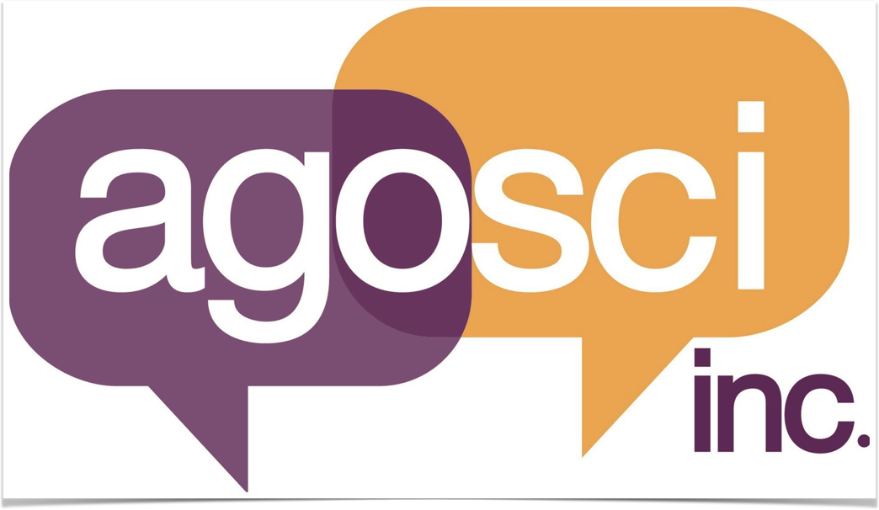

Terms of Reference for AAC Communicators role,

Co-Representative and Regional Mentor program roles

Background

The purpose of this document is to outline the new roles the Executive Committee of AGOSCI, ‘Australia’s AAC Community’ have endorsed and will start recruiting for upon the public release of this document. The terms of reference for applying for the roles, how the mentoring will be monitored and the desired outcomes for these positions will be laid out below.

AGOSCI proposes the establishment of some new AAC communicator positions. These positions are as follows:
- AAC Communicator Co-Representative
- State AAC mentor roles (5-6)

These new positions were shared with AGOSCI members at the 2019 biennial conference in Perth. For those not in attendance at the conference, please see below the information shared at the conference by Lisa Lehmann (AAC Communicator representative for AGOSCI executive):

“So when I started in this role in 2017, there wasn’t much of a position description or any kind of structure or succession planning generally, and I’m that person who needs to have clarity in the purpose of my various roles; so I floundered in my role for the first year, then did some reflection to assess and review whatever my input was; What email threads and discussions did I engage in, basically what did I feel I contributed to the work we all do behind the scenes. Then at last years (2018) annual face to face planning meeting, the suggestion of a role name change and the possibility of creating a co-rep position. At first I thought maybe the exec team were trying to hint to either pick up your game, or ship out. But I think the other members started to realise the full potential of this role.

So for the last year I have been writing the position descriptions for the AAC user representative role, and I wanted to let you know about these few exciting initiatives AGOSCI executive has given the green light to do. So, we’ve decided to create several new roles for AAC users, to start to drive the organisation from a grassroots/member’s level.

I’ve created a role description for a co-representative, the main proviso for this position is to live in a different state to the other representative, I’m from Queensland, and I’m hoping to be able to stay in the role for as long as it takes to see this project come to bloom and can keep contributing towards the growth of AGOSCI; so it’d be great to have another person from another state so we can share different regional perspectives and connect more with AAC users, and their families/communication partners.

The second thing we identified Is that even with 2 representatives, we still won’t have the knowledge of all the different modalities that people use to communicate with from an end user perspective. This brings me to the other positions we’ve created. The mentor program will be managed by myself and the co-representative, when that position is filled.

I have planned for roughly 12 mentors in the program. The mentor position descriptions will be available online in the next two weeks, and will be open for expressions of interest then too. And we will be changing the AAC user representative title to AAC communicator representatives. This is a decision I’ve made without the full executive’s agreement; however it has been flagged with me since I was elected into the position. After having many discussions with different people about how they describe themselves as people who use assistive communication; there was a common theme around the negative connotations that the word user; so although it makes the title a bit long, we may end up shortening it down the track.

We had already flagged the co-representative role, then we took it a step further, to start true grassroots mentoring by people who use AAC, to support new and emerging AAC communicators. This will help to make AGOSCI truly live up to its slogan of - Australia’s AAC community.”

Conclusion to introduction

After further reflection, the proposal was altered to recruit 5-6 AAC mentors rather than 12. This was thought too large a number to start if this proposal was to succeed. Recruitment is to begin for 5-6 AAC Mentors to attend a 1 day induction run by a professional development facilitator, for the mentor roles across Australia to meet face to face for an induction day, running on the afternoon of the 2021 AGOSCI pre-conference workshops on 1st of September 2021. This inaugural induction day will outline the responsibilities of the AAC communicator reps and AAC mentors, and how AGOSCI can provide support. Benefits of the induction will include sharing knowledge and experiences, meeting old and new members; and supporting new and emerging communicators. We will be working on two-year term appointments when the positions start.

The induction will give successful applicants the chance to help shape and form this project for future successors to follow. The induction will also help to support this project to grow organically. Part of the induction will be around making this project self-sustaining, meaning generating ways to make money to keep the project going. One such plan is tapping into and lobbying for funding through local council, state, and national grants. We will also aim to identify capacity building funding available to peak bodies, with the possibility of developing community events to create awareness around different communication modalities working under AGOSCI’s reputation as a peak body in the professional space.

The induction process includes the opportunity to attend the conference and meet new and old faces, to give general conference attendees a chance to meet our new team of AAC Mentors and create more connections. The AAC Communicator Co-Representative will attend the annual planning meeting (held on the 5th of September), general conference and mentoring induction.

The Objectives

This project is as simple as our slogan, as has been mentioned above, the mission for the AAC Mentors Project is:
- to fully represent AAC Communicators in this country
- to recognise the diversity of our membership base
- to tap into local networks to help bring about awareness of AAC

What better way to represent AGOSCI as an organisation than to recruit the very people this organisation represents?

This must be a win/win situation for all, so when representing AGOSCI in your local area or further away, you will not be out of pocket, and will compensated for your time in some way, this will be negotiated once we can establish an ongoing stream of funding to maintain this project.

The aim is to make this project self-sustaining, which will come as the project grows. Whilst there are boundaries around this, it has the potential for more growth, as we are using the scale up model.

Please be aware that as this is the first pilot program within an organisation in Australia, we have only been able to budget enough to make the initial induction training happen. There can be no guarantees that this project will be sustainable, however, the AGOSCI executive remain optimistic. We do have some ideas to make this project generate income and to offer small bursaries to those who are proactive in their roles and run community events, present a webinar, and facilitate interactive discussions. These are just a few ideas AGOSCI has flagged, with feedback from the appointed parties upon induction.

Position Descriptions

AAC Communicators Representative

The primary purpose of the role of the AAC user representatives is to bring the expertise that is derived directly from lived experience to the discussions and work that AGOSCI-executive committee does behind the scenes. The role of the co-representative will be to assist in managing and communicating with our members, the co-representative, will then step into the AAC communicator role when the person has served as much as they have the capacity to do so. This is also to ensure succession planning for the vital continuity of the organisation.

Duties and responsibilities

This role requires the following commitments:
- Ability to engage with email discussion threads where you can add value, or provide personal responses to issues and current work the organisation is undertaking
- Lived experience is crucial to add to the advancement of AAC awareness on a national level
- Represent AAC Communicator mentors project on a local, state and national level
- Engage with the peer mentors in your region/s
- Build your networks both in the sector and generally in your regions
- Support AAC communicator mentors in your region/state
- General understanding of Zoom to host events both electronically and in person
- Represent AGOSCI at other events and non AGOSCI run conferences
- Report regularly to the executive committee of any issues members bring to you ion this role

Abilities and skills
- Easy English literacy skills
- Competent at email correspondence
- Bring lived experience to the team
- A positive public media presence
- Understanding of the responsibilities outlined above and willingness to learn about committee rules, constitution and general understanding of not for profit boards and executive committees
- Positive attitude with a dash of critical thinking!

AAC Communicator Co-Representative

position description

Requirements are the same as the AAC communicator representative as these roles run parallel, there is no vertical structure in the hierarchy of positions in this recruitment phase. In addition, the AAC communicator co-representative must meet the following requirements, or be willing to learn more about certain aspects.
- Must live in a different state to the primary AAC representative.
- Does not have to have attend exec meetings, but can attend if they wish
- The person selected for this role will step into the primary AAC Communicators Representative role when they leave the position. This is to develop succession planning for the committee and to sustain the actions put in place.
- The co-rep role will assist in similar duties where practical in place of the primary representative and will act as proxy when necessary.
- The primary representative will act as a mentor to assist the co-rep learn the national executive committee functions and the skills and responsibilities for executive committee members.
- The co-rep will assist in supporting the regional mentors and assist with linking the right people within our membership and larger AAC community.

*This position will need to be passed to vote by the committee for successful applicant and will be obliged to attend an inaugural meet and greet zoom meeting, and face to face meetings wherever possible

AGOSCI AAC Mentor (region) Representative

Possibly the most integral role of all in this project, we NEED you, if you know your local area and region, if you can link more people to create our very own AAC community in the country, if you are an AAC Communicator and you have lots to give, but nowhere to direct it, please apply!

Each mentor will be chosen on a number of factors, such as:
- Location (as we want to be as diverse and widely distributed in regions where AGOSCI is not as represented)
- Connection to your region and your community
e.g. business/political/social/special interest/disability services/general/ community members.
- Ability to model your methods of communication for new and emerging communicators
- Ability to learn about others AAC systems/general understanding of different modalities of communication
- Capacity to commit to represent AGOSCI at local expos and online discussions relating to your region and your personal passions within the sector.

**although we understand capacity is at times out of our control, as we have lived experience with unstable health and life generally*.

Conclusion
This project has now become time sensitive as the executive committee was successful in securing a small yet substantial grant, with much honour from the “Suzanne Elliott Charitable Trust” (SECT). This will enable us to support 6 people who communicate via AAC who are planning on attending the AGOSCI 2021 Conference in Hobart, Tasmania to attend the half day AAC mentor program induction, on the afternoon before the conference starts. Running this in conjunction with the conference will give the inductees the chance to follow up on any further discussions throughout the conference also. Having this opportunity to work with such a progressive thinking charity is a great honour, and we look forward to sharing some great outcomes with the launch of this project. Please find below more information about The Trustee for Suzanne Elliott Charitable Trust

“The Suzanne Elliott Charitable Trust supports the development of strong, healthy, connected, and flourishing communities through the provision of funding support. It aims to support innovative ideas that contribute to the development of connected, equitable and generous communities. Our funding strategy targets project support for specific programs, capacity building in individuals and communities and general operating support. The Suzanne Elliott Charitable Trust provided grants to applicants that met with the goals of the trust.”

For more information about this document and project please contact Lisa Lehmann via text on 0419796798, or on email littlebigwitch@yahoo.com.au

