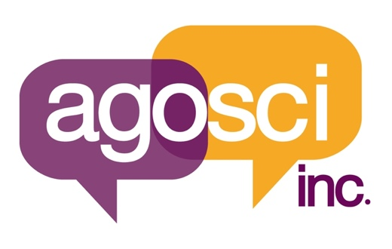

Expressions of interest for

The purpose of this form is to facilitate the appointment of the new positions created by the inaugural project for one co-representative, and six aproximately (6) AAC Regional mentors in the nomination process. Any AGOSCI member who communicates via AAC is encouraged to submit nominations for the following positions

- AAC Co-Representative
- AAC Communicator Mentors x 6

Confirmation of willingness of the nominee to serve is essential and completion of this form must be submitted by 28th June 2021

All expressions of interest must be from current AGOSCI members.

I, [ Name ] confirm my willingness to be considered for the Co-Representative/AAC Mentor. (please indicate by highlighting/deleting which role/s you wish to be considered for).

Name of Nominee:
Affiliation:
Mailing Address:
Telephone: Fax:
E-mail:
Signature: Date:

Biographical Sketch including interest in nominated role (Miniumum 50 words maximum 1 page):

(Signature of Nominating AGOSCI Member

Further information required:

Although AGOSCI has received a small grant to get this program started, we are not in a position financially to cover all costs of each inductee. Some funding will be covered as our budget allows.

To help us to allocate funding, could you please supply us with the following information:

If you are successful in your application for any of the roles will you be able to meet the balance of costs required for your attendance at the conference?

- Yes
- No

Please complete the table below to give us an idea of the total costs you will face in attending the conference. This table is not compulsory to complete, but will help us to allocate funds for each participant. Please consider any other funding you may receive:

ITEM | Expected Costs
Flight

Accommodation

Costs associated with Attendant Care (Attendant care is not provided by the conference organisers)

Conference Registration

Food / Drink

Transport around city

Spending money

Other (please describe)

FUNDING SUPPORT

Do you have access to any other form of funding support for your trip?

- Yes
- No

If yes, please give details of where this funding arises:

- personal funds: amount: ______________
- other funding secured: ______________
- other (detail) : __________________________

Please return this form by 28/06/2021 to:
Lisa Lehmann lisa.lehmann@bigpond.com or
Email Melissa Bakes, Secretary AGOSCI agoscisecretary@agosci.org.au

Thankyou.

